Experiment-2
Write a python program to solve 8 Queen problem
Aim
To write and execute a Python program to solve the 8-Queens Problem using the Backtracking algorithm, such that no two queens attack each other.
Algorithm
- Start with an empty 8 × 8 chessboard.
- Place a queen in the first row.
- Check whether the selected position is safe.
- A position is safe if no queen is present in the same column or diagonal.
- If the position is safe, place the queen and move to the next row.
- If no safe position is available, backtrack to the previous row.
- Move the previously placed queen to another safe position.
- Repeat the process until all 8 queens are placed.
- Display the chessboard with the positions of all queens.
- If no valid arrangement is found, display No solution exists.
Coding
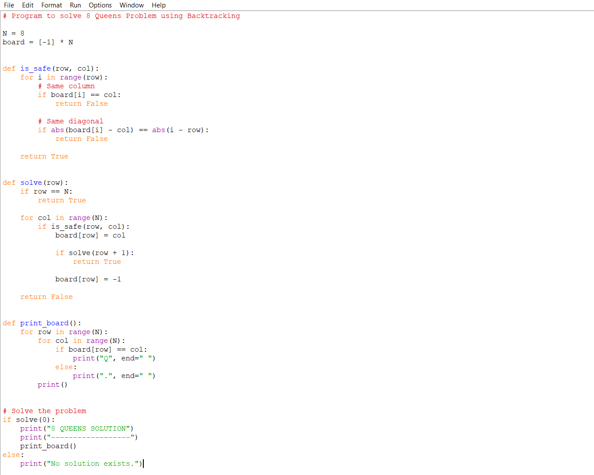
Output
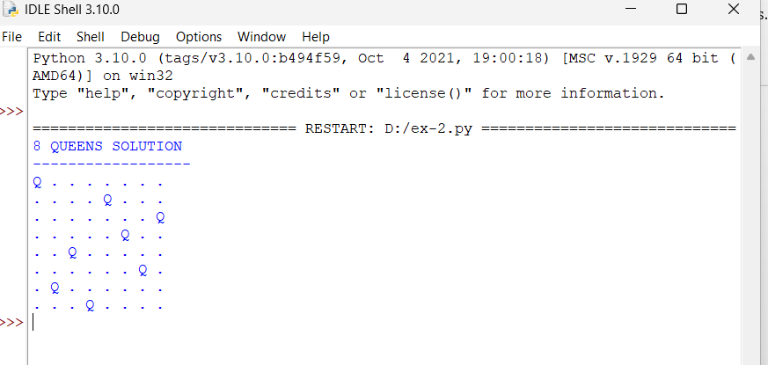

Result
The 8-Queens Problem was successfully solved .The program finds a valid arrangement of 8 queens on an 8 × 8 chessboard such that no two queens attack each other.

